1. Assume that jobs A-D arrive in the ready queue in quick succession and have the CPU cycle requirements listed below. Using the Shortest Remaining Time Next algorithm

a) The average waiting time is __**2.75**__

b) The Turnaround time of job D is **6**

c) The Waiting time of job A is __**8**__.

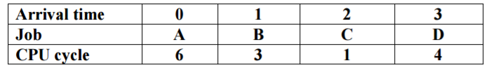

2. A ssume that four jobs A-D require the CPU cycles listed below. Using the Shortest Job First algorithm, the __**C**__ job is run first.

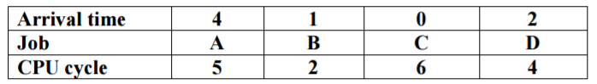

3) A ssume that four jobs A-D require the CPU cycles listed below. Using the Round-Robin algorithm with time slide equaling 4, the average of turnaround time of one process is __**10.5**____ .

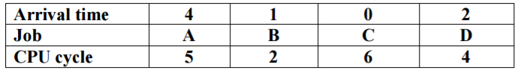

4) Assume that four jobs A-D require the CPU cycles listed below. Using the Shortest Job First algorithm, the average waiting time is __**4.75**__.



5) A ssume that four jobs A-D require the CPU cycles listed below. Using the Round-Robin algorithm with time slide equaling 4, the waiting time of all process is __**25**____ .

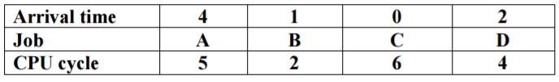

6) Assume jobs A-D arrive in quick succession in the READY queue. Using round robin scheduling with time slice equaling 4, the turnaround time for job D is __**22**__.

| **Arrival time** | **0** | **1** | **2** | **3** |
| --- | --- | --- | --- | --- |
| **Job** | **A** | **B** | **C** | **D** |
| **CPU cycle** | **8** | **4** | **9** | **5** |

7) Assume jobs A-D arrive in quick succession in the READY queue. Using shortest job first scheduling, the average turnaround time for each process is __**14.25**__.

| **Arrival time** | **0** | **1** | **2** | **3** |
| --- | --- | --- | --- | --- |
| **Job** | **A** | **B** | **C** | **D** |
| **CPU cycle** | **8** | **4** | **9** | **5** |

8) Assume jobs A-D arrive in quick succession in the READY queue. Using shortest remaining time next scheduling, the average waiting time for each process is __**6.5**__.

| **Arrival time** | **0** | **1** | **2** | **3** |
| --- | --- | --- | --- | --- |
| **Job** | **A** | **B** | **C** | **D** |
| **CPU cycle** | **8** | **4** | **9** | **5** |

9) Assume that four jobs A-D require the CPU cycles listed below. Using the Shortest Job First algorithm, the _**B**_ job is run first.

| **Job** | **A** | **B** | **C** | **D** |
| --- | --- | --- | --- | --- |
| **CPU cycle** | **5** | **2** | **6** | **4** |

10) Assume jobs A-D arrive in quick succession in the READY queue. Using round robin scheduling with time slice equaling 4, the turnaround time for job C is ______**16**______

| **Arrival time** | **0** | **1** | **2** | **3** |
| --- | --- | --- | --- | --- |
| **Job** | **A** | **B** | **C** | **D** |
| **CPU cycle** | **4** | **5** | **5** | **4** |

11) Assume jobs A-D arrive in quick succession in the READY queue. Using shortest job first scheduling, the average turnaround time for each process is ____**9.25**_______ .

| **Arrival time** | **0** | **1** | **2** | **3** |
| --- | --- | --- | --- | --- |
| **Job** | **A** | **B** | **C** | **D** |
| **CPU cycle** | **4** | **5** | **5** | **4** |

12) Assume jobs A-D arrive in quick succession in the READY queue. Using shortest remaining time next scheduling, the average waiting time for each process is ____**4.75**______.

| **Arrival time** | **0** | **1** | **2** | **3** |
| --- | --- | --- | --- | --- |
| **Job** | **A** | **B** | **C** | **D** |
| **CPU cycle** | **4** | **5** | **5** | **4** |

13) Assume jobs A-D arrive in quick succession in the READY queue. Using round robin scheduling (quantum=4), the average turnaround time for each job is ___**18.25**_____ .

| **Arrival time** | **0** | **1** | **2** | **3** |
| --- | --- | --- | --- | --- |
| **Job** | **A** | **B** | **C** | **D** |
| **CPU cycle** | **8** | **4** | **9** | **5** |

1. Five batch jobs A through E, arrive at a computer center at almost the same time. They have estimated running times of 8, 6, 2, 10, and 4 minutes. Determine the mean process average turnaround time for SJF (Shortest job first) scheduling. Ignore process switching overhead.  
     **Answer : 14 minutes**